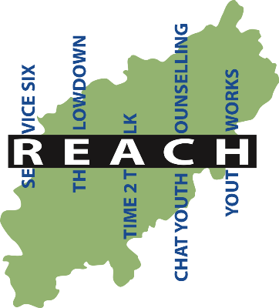

Job Description

RE:Start Support Worker (West)

Post: | RE:Start Support Worker (West)
Responsible to: | RE:Start Manager
Responsible for:
Work location: | Based in Northampton but covering the whole of the west of Northants
Salary range: SCP 2 - 4 £25,726 FTE
Contract: | Fixed term over two years
Hours: | 1 x Full-time / potentially 2 x part-time / Jobshare  Flexible working to meet the requirement of the role.  Will include occasional evening and weekend hours.

About The Reach Partnership
The REACH partnership is an umbrella organisation of Northamptonshire based youth counselling and emotional wellbeing support agencies. The REACH partnership delivers a range of counselling and support services to young people. The partnership is commissioned to deliver mental health support to young people transitioning from adolescent to adult services.

RE:Start Team
Youth Works, on behalf of the REACH partnership of Youth Counselling services
In Northamptonshire have been commissioned by NHS Northamptonshire to deliver an exciting service to support young people making the transition from Child and Adolescent Mental Health Services to Adult Mental Health Services.

This can be a difficult and challenging time for many young people. Support will be offered to young people via a referral system. The Transitions Team Service will introduce young adults to the comprehensive crisis pathway available across Northamptonshire, and will ensure co-produced, personalised Safety Plans for each young adult, to help avoid unnecessary attendance at emergency departments. Progress will be monitored through an agreed outcome measure.

The Service will use a 'Personal Assistant (PA)' approach to ensure a flexible, holistic approach to care. It will have the capacity to work with CYP from 16 years - building trust and gaining a robust understanding of needs - and to remain involved with young adults up to the age of 25 to ensure a gradual transition into adulthood.

The ethos and culture of the service will be solution-focused, strengths-based, personalised, flexible and will be able to work with a complex set of needs, regardless of diagnosis.

There will be two teams of support workers, one in the north of the county and one in the west.

Job Purpose
To support the development of and deliver the transitions service to young people in the West of the county.

General Duties

- Deliver a range of quality support services including assessment, casework, workshops and activities and signposting based on the presenting needs of the client group.

- Ensure a clear referral pathway into the service is maintained.

- Provide casework support to a caseload of clients.

- Ensure personalised safety plans are completed for all clients.

- Adopt a person approached to the work, based on the I Thrive and trauma centered principles.

- Offer ongoing support with related issues eg. housing, finances, access to education, employment or training, socialization and community support, support with any drug or alcohol issues through direct support and signposting. Support the development of a local database of agencies regarding signposting.

- Ensure all monitoring outcomes data is recorded and input.

- Contribute to the presentation of monthly statistical reports and any written reports, case studies and summaries of service delivery.

- Contribute to 3 monthly evaluation reports for the service.

- Support and ensure the input of users into the service development through a user group.

- Participate in regular team meetings and ensure that team meeting minutes are read and acted upon

- Contribute to sharing practice and specialised information and support through county briefings and collaborations.

- Collaborate effectively with GPs, local NHS providers (eg CAMHS etc tbc) in order to receive and make appropriate referrals.

- Provide support to volunteers working within the teams.

Organisation Duties

- Adhere to and remain current with The Lowdown’s policies and procedures which include but are not limited to: Equality & Diversity; Safeguarding; Health& Safety; and Confidentiality.

- Attend 6 weekly supervision with the manager and 6 weekly group clinical supervision.

- Undertake all relevant administrative tasks.

- Attend any other additional meetings and training as required.

Asylum, Immigration and Nationality Act (2006)
In order to comply with the Asylum, Immigration and Nationality Act 2006, offers of employment will not be made to any applicant or employee who does not have the appropriate documents to prove their right to work in the UK.

Safeguarding

Positions within the lowdown Northamptonshire are exempt from the Rehabilitation of Offenders Act 1974. Any offer of employment is conditional upon the lowdown receiving an Enhanced Disclosure from the DBS which the Organisation considers to be satisfactory and satisfactory references.

Positions within the Lowdown Northamptonshire are exempt from the Rehabilitation of Offenders Act 1974 and the amendments to the Exceptions Order 1975, 2013 and 2020.

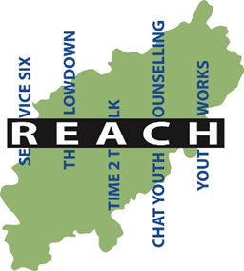RE:Start Support Worker - Person Specification

 | Essential criteria | Desirable criteria | Evidenced  A = application  I = interview  R = reference
Education  /Knowledge | G.C.S.E level C (or equivalent) in Maths and English  A relevant Level 3 equivalent qualification (eg A levels, HND etc) | A professional qualification in a related field eg social work, youth work, teaching, counselling | A
Skills | Excellent written and spoken communication skills applied in a range of settings (teams, 1 to 1, partner agencies) |  | A
 | Skills in counselling and/or emotional support or case work with young people/young adults | Experience in a related field (eg housing, addictions, employment, benefits. | A
 | Good time management and organisational skills |  | R/I
 | Computer literacy and inputing data | Good knowledge of Microsoft / Google suite of products | A
 | Ability to manage own workload and diary |  | R
Experience | Experience of working with young people and mental health | Experience of partnership work and networking across delivery agencies | A
 | Experience of evidencing work delivered/completing monitoring reports/completing client related paperwork | Experience in developing safety plans/risk assessments | A
Other attributes | A passion for working in the community and a commitment to the values and ethos of Youth Works/REACH | Flexible attitude to work and able to demonstrate an excellent work ethic | A
 | Ability to communicate clearly and take into account, where appropriate, the views of others |  | R/I
 | An understanding of confidentiality and safeguarding |  | R/I
 | Full driving licence/ability to travel to locations across the county |  | R/I
 | Able to work flexibly – including evening and weekend work |  | R/I

